2024-2025
TFRW BOARD OF DIRECTORS’ BOOK

EXECUTIVE COMMITTEE

POSITION | NAME | CONTACT INFORMATION
President | Sharon Boreing | 1319 McCoy Circle  Jonesborough, TN 37659  423-741-6968  www.rocknhill@comcast.net
First Vice President | Millie Gump | 3068 Bentwood Run Drive  Collierville, TN 38017  901-292-7891  milgump@aol.com
Second Vice President | Sharon Ohsfeldt | 2464 Cedar Dale  Germantown, TN 38139  901-590- 7946  sobridge123@gmail.com
Recording Secretary | Cathy Kolb | 307 Longwood Court  Clarksville, TN 37043  931-801-6954  cathykolb@reagan.com
Corresponding Secretary | Susan Kirk | 207 Chota Hills Lane  Loudon, TN 37774  352-220-0804  smkirk1978@gmail.com
Treasurer | Stacey H. Brewer | 321 Copeland Drive  Waynesboro, TN 38485  931-722-0689  stacey@waynecountybank.com
Vice Treasurer | Deborah Bailey | 670 Washington Avenue  Harrogate, TN 37752  606-273-7279  cincydebb@icloud.com
Past President | Linda Kollmann | 4637 Sterling Cross  Nashville, TN 37211  615-498-1951  LindaKollmann@bellsouth.net

AREA VICE PRESIDENTS

POSITION | NAME | CONTACT INFORMATION
Area 1A | Kara Sanders | 611 Glen Oaks Place  Gray, TN 37615  423-341-5115  kssanders93@embarqmail.com
Area 1B | Emily Poe | 390 Poes Lane  Bulls Gap, TN 37711  423-293-2761  emily@eandeexcavating.com
Area 1C | Tina Swatzell Harbison Riggs | 1584 Pleasant View Dr.  Talbot, TN 37877  423-312-1783  tinariggs@gmail.com
Area 2 | Julia Atchley Pace | 509 Smokey Branch Vonroe, TN 37885 423-836-7192 423-295-2766 achievementacademy@msn.com
Area 3A | Amy Poteet | 107 Arcadia Ln Apt D Oak Ridge, TN 37830 865-801-6081 Sapoteet90@gmail.com
Area 3B | Rebecca Whiddon | 840 Waterthrush Lane  Chattanooga, TN 37419  423-208-1700  whiddonrebecca@gmail.com
Area 4A | Gloria Hutcherson | 132 Motthaven Road  Crossville, TN 38588  516-971-6435  everglow212@gmail.com
Area 4B | Susie Bowers | SUSIE BOWERS  PO Box 322  Estill Springs, TN 37330  931-308-9045  sbowers1961@gmail.com

AREA VICE PRESIDENTS CONTINUED

POSITION | NAME | CONTACT INFORMATION
Area 5A | Anne Hildebrand | 3019 Huntsman Drive  Gallatin TN 37066  304-633-5631  Anne.hildebrand5631@gmail.com
Area 5B | Yvonne Hunter | 46 Dixon Springs Circle Box 84  Dixon Springs, TN 37057  615-709-1111 or 615-509-2541  yghunter@bellsouth.net
Area 6 | Cheryl Brown | 500 Kilburn Court  Franklin, TN 37067  615-870-6188  cherylgop23@gmail.com
Area 7A | N’Gaio Wesenberg | 186 Vantage Pointe  Counce, TN 38326  731-514-7086  ngaio@centurytel.net
Area 7B
Area 8A | Katana Hawks | 170 Bizzle Lane  Martin, TN 38237  731-343-1582  katanahawks2002@yahoo.com
Area 8B | Jen Free | 44 Maryland Drive  Jackson, TN 39301  731-394-0921  jfree@byrdslaw.com
Area 9 | Barbara Capozella | 10389 Shea Woods Dr  Collierville, TN 38017  920-370-5517  bcapozella@yahoo.com

STANDING COMMITTEES

POSITION | NAME | CONTACT INFORMATION
Bylaws | Jennifer Little | 352 Koasati Rd  Bean Station, TN 37708  423-736-0731  jilittle08@gmail.com
Campaign Activity | Barbara Trautman | 3089 Oakleigh Lane  Germantown, TN 38138  901-262-6821  bbtbabs@aol.com
Fundraising | Linda Kelley | 408 Alexander Ave  Church Hill, TN 37642  423-293-2761  Lindakelley71141@gmail.com
Legislation | Barbara Boswell | 679 Headtown Rd  Jonesborough, TN 37659  423-791-3273  bsboswl@comcast.net
Membership Chair | Jean Huntsman | 1477 Darbee Drive  Morristown, TN 37814  423-231-7653  jeanhunt@yahoo.com
Public Relations | Joan Guggenheim | 109 Park Drive  Jonesborough, TN 37659  423-791-2970  joangugg@guggie24.com

SPECIAL COMMITTEES AND APPOINTEES

POSITION | NAME | CONTACT INFORMATION
Achievement Awards | Millie Gump | 3068 Bentwood Run Drive  Collierville, TN 38017  901-292-7891  milgump@aol.com
Americanism | Felicia Hix | 2825 Stonehenge Drive  Murfreesboro, TN 37128-7606  931-224-2273  felicia.hix@gmail.com
Armed Forces/Homeland Security | N’Gaio Wesenberg | 186 Vantage Pointe  Counce, TN 38326  731-541-7086  ngaio@centurytel.net
Beyond the Vote | Whittney N.L. Good | 303 Bullington Avenue  Bulls Gap, TN 37711  423-748-4115  whittneynlgood@yahoo.com
Caring for America | Robbyn Maylott | 612 Sugar Hollow Road  Telford, TN 37690  423-418-2036  robbynmaylott@outlook.com
Chaplain | Debbie Corey | PO Box 584  Chuckey, TN 37641  423-502-1702  dcorey601702@icloud.com
Eagle Forum Lobbyist | Bobbie Patray | 3216 Bluewater Trace  Nashville, TN 37217  615-838-4415  bobbie@tneagleforum.org
Mamie Eisenhower Library Project Chair | Dr. Charlene Thomas | 104 Quail Run  Johnson City, TN 37601  423-483-4665  cthomastngmail.com

SPECIAL COMMITTEES AND APPOINTEES CONTINUED

POSITION | NAME | CONTACT INFORMATION
Facebook Admin. | Susan Witcher | 203 Witcher Hollow Road  Red Boiling Springs, TN 37150  615-655-3596  switcher@nctc.com
Financial Review | Gayle Bennett | 4562 Whisperwood Drive  Collierville, TN 38017  954-557-7763  bennettgb@aol.com
Government Financial Reporting | Stacey H. Brewer | 321 Copeland Drive  Waynesboro, TN 38485  931-722-0689  stacey@waynecountybank.com
Barbara McAndrew Iris Fund | Barbara Trautman | 3089 Oakleigh Lane  Germantown, TN 38138  901-262-6821  bbtbabs@aol.com
Muffet Brock Award | Jean Huntsman | 1477 Darbee Drive  Morristown, TN 37814  423-231-7653  jeanhunt@yahoo.com
Parliamentarian | Judy Oxford | 480 Sugartree Lane Suite #520  Franklin, TN 37064-3083  615-791-8511  judyaoxford@comcast.net
Photographer | Janet Barcroft | 406 Wandering Trail  Franklin, TN 37067  615-415-8655  jbarcroft@comcast.net
Protocol | Mary Obersteadt | 9114 Sawyer Brown Road  Nashville, TN 37221  615-598-3843  maryo.nrw@gmail.com

SPECIAL COMMITTEES AND APPOINTEES CONTINUED

POSITION | NAME | CONTACT INFORMATION
Regents-Tennessee | Jennifer Little | 352 Koasati Rd  Bean Station, TN 37708  423-736-0731  jilittle08@gmail.com
Resolutions | Cathy Kolb | 307 Longwood Court  Clarksville, TN 37043  931-801-6954  cathykolb@reagan.com
Sergeant-at-Arms Chair | Shaila Stewart | 289 Old Troy Road  Martin, TN 38237  (C) 407-252-3049  softballmama333@aol.com
State Ex. Com Liaison | Patricia Allen | 466 Pond Apple Road  Clarksville, TN 37043  931-216-4090  tomeallentom@netscape.net
Technology Chair | Sharon Ohsfeldt | 2464 Cedar Dale  Germantown, TN 38139  901-590-746  sobridge123@gmail.com
Webmaster | Patti Possel | 581 Fern Meadow Cove  Cordova, TN 38018  901-246-9925  papossel@comcast.net

CLUB PRESIDENTS

AREA | CLUB NAME CONTACT INFO
1A | Greater Kingsport Republican Women | Linda Figliolino | 1910 Birchfield Prive Dr  Kingsport, TN 37660  423-760-567-8598  lindafigliolino19442gmail.com
1A | Washington Co. Federated Rep. Women | Brenda Frizzell | Bondwood Drive  Johnson City, TN 37604  434-989-3470  wcrwtn2gmail.com
1B | America First Federated Rep. Women | Deborah Corey | PO Box 584  Chuckey, TN 37641  423-502-1702  dcorey601702@icloud.com
1B | Cocke Co. Federated Rep. Women | Macie Reed | 215 Pearl Meadow Way  Del Rio, TN 37727  423-608-4036  macie.reed@cot.tn.gov
1B | Greene Co. Rep. Women | Joy Rader Nunnally | 1110 East Allens Bridge Rd  Greeneville, TN 37743  423-552-8793  jump4joyr@yahoo.com
1B | Sevier Co. Rep. Women | Cyndi Pickels | 125 Court Ave., Suite 209W  Sevierville, TN 37862  865-719-3238  cpickle@seviercountytn.gov
1C | Grainger Co. Rep. Women | Gisela Eicky-Carr | 496 Robbins Road  Rutledge, TN 37681  423-312-7693  tngigi@live.com
1C | Hamblen Co. Rep. Women | Gail Pedigo | 508 Windridge Lane  Morristown, TN 37814  931-212-8580  gailpedigo1969@gmail.com

CLUB PRESIDENTS CONTINUED

AREA CLUB NAME CONTACT INFO
2 | Blount Co. Rep. Women | Heather Clayborne | 239 Blockhouse Road  Maryville, TN 37803  865-770-1272  heather.clayborne@gmail.com
2 | Loudon Co. Rep. Women | Sandy Kennel | 157 Utsesti Trace  Loudon, TN 37774  615-429-0010  sanmroken@gmail.com
2 | McMinn Co. Rep. Women | Laura Floyd | 1500 Pennsylvannia Ave  Etowah, TN 37331  423-435-5749  laurafloyd7@gmail.com
2 | Monroe Co. Rep. Women | Janie Harrill | 1215 Stephens Drive  Madisonville, TN 37354  423-836-7192  janieandbumpy2gmail.com
2 | Rep. Strong Federated Women | Susan Kirk | 207 Chota Hills Lane  Loudon, TN 37774  352-220-0804  Smkirk1978@gmail.com
3A | Anderson Co. Federated Rep. Women | Amy Poteet | 107 Arcadia Ln Apt D  Oak Ridge, TN 37830  865-801-6081  Sapoteet90@gmail.com
3A | Campbell Co. Rep. Women | Jennifer Higginbotham | 1126 Cross Valley Road  LaFollette, TN 37766  423-494-0165  jenniferh1998@yahoo.com
3A | Roane Co. Rep. Women | Barbara Sanders | 155 Deer Run Ridge Road  Kingston, TN 37763  865-376-7105  tupperwaretransformation@gmail.com

CLUB PRESIDENTS CONTINUED

AREA | CLUB | NAME | CONTACT INFO
3B | Bradley Co. Rep. Women | Emily Nekhela | 1804 Stuart Ave  Cleveland TN 37311  423-284-5060  emilysrbon@hotmail.com
3B | Chattanooga Rep. Women | Marsha Yessick | 622 West Brow Rd  Look Out Mountain, TN 37350  423-316-1127  msyessick@aol.com
3B | Hamilton Co. Rep. Women | Vickey Rockwood | 9194 Woodland Drive  Ooltewah, TN 37363  423-432-2377  vkraglow@gmail.com
3B | Tennessee Valley Rep. Women | Joyce Sulzycki | 7119 Tea Berry Court  Ooltewah, TN 37363  423-503-7259  sulzyckij@gmail.com
4A | Rep. Women of the Upper Cumberland | Abby Williams | 208 N. Jefferson Ave  Cookeville, TN 38501  931-526-4163  ryabby@charter.net
4B | Franklin Co. Federated Rep. Women | Sheila M. Williams | P.O. Box 188  Monteagle, TN 37356  931-224-3225  tennesseans2@blomand.net
5A | Montgomery Co. Rep. Women | Tina Englen | 1089 Jon Drive  Clarksville, TN 37043  931-249-3605  Tina.englen@yahoo.com
5A | Nashville Rep. Women | Mary Obersteadt | 9114 Sawyer Brown Road  Nashville, TN 37221  615-598-3843  maryo.nrw@gmail.com

CLUB PRESIDENTS CONTINUED

AREA | CLUB | NAME | CONTACT INFO
5A | Sumner Co. Rep. Women | Melissa Gay | 136 Chesapeake Harbor Road  Hendersonville, TN 37075  615-957-8382  Jcil2me@bellsouth.net
5A | Red River Rep. Women | Cathy Kolb | 307 Longwood Court  Clarksville, TN 37043  931-801-6954  cathykolb@reagan.com
5A | Rep. Women of Sumner | Jill Rathert | 101 William Shy Dr.  Hendersonville, TN 37075  615-476-8462  jillrathert@gmail.com
5B | Mt. Juliet Rep. Women | Debbie Moss | 9418 Beckwith Road  Mt Juliet, TN 37122  615-866-8435  mossmtjuliet1@aol.com
6 | Rep. Women of Marshall Co. | Terri Fenn-Argo | 3177 Nashville Hwy  Lewisbury, TN 37091  615-593-4330  ejones1126@att.net
6 | Rep. Women of Maury Co. | Cindy Rial | 304 Kippsford Pond Road  Columbia, TN 38401  931-626-6204  rialc@charter.net
6 | Rep. Women of Rutherford Co. | Karen Hudson | 2010 Stratford Road  Murfreesboro, TN 37129  615-584-7478  karenwhudson@comcast.net
6 | Rep. Women of Williamson Co. | Debbie Ballard | 656 Good Springs  Brentwood, TN 37027  615-293-8003  debbie8657@aol.com

CLUB PRESIDENTS CONTINUED

AREA | CLUB | NAME | CONTACT INFO
6 | Williamson Co. Rep. Career Women | Sherry Anderson | 7208 King Road  Fairview, TN 37064  615-417-4746  sherryda100@yahoo.com
7A | Hardin Co. Rep. Women | Shirley Benson | 121 Blythe Street  Savannah, TN 38372  731-607-0087  Shirleybenson1948@gmail.com
7A | Lawrence Co. Rep. Women | Rebecca Taylor | 310 Turnpike Road  Lawrenceburg, TN 38464  615-517-2787  tnttaylors@yahoo,com
7A | Lewis Co. Federated Rep. Women | Virginia Breedlove | 168 Commanche Drive  Hohenwald, TN 38462  805-623-3452  sunnyskies653@gmail.com
7A | McNairy Co. Rep. Women | Patricia Underwood | 60 Twin View Cv  Selmer, TN 38375  731-610-0722  trishunderwood1010@gmai.com
7A | Pickwick Rep. Women | Cherly DeBois | 35 Oak Hollow Road  Counce, TN 38326  901-299-3886  gdubose1@comcast.net
7A | Wayne Co. Rep. Women | Stacey H. Brewer | 321 Copeland Drive  Waynesboro, TN 38485  931-722-0689  stacey@waynecountybank.com
7B

CLUB PRESIDENTS CONTINUED

AREA | CLUB | NAME | CONTACT INFO
8A | Weakley Co. Rep. Women | Katana Hawks | 170 Bizzle Lane  Martin, TN 38237  731-343-1582  katanahawks2002@yahoo.com
8B | Madison Co. Rep. Women | Peggy Ramsey | peghashope@icloud.com
9 | Fayette Co. Rep. Women | Elizabeth Rosser | 116 Robertson Drive  Somerville, TN 38068  901-413-4319  dphbeth@aol.com
9 | Rep. Women of Purpose | Barbara Trautman | 3089 Oakleigh Lane  Germantown, TN 38138  901-262-6821  bbtbabs@aol.com
9 | Shelby Co. Rep. Women’s Club | Sharon Webb | 3569 McCorkle Road  Memphis, TN 38116  901-692-0949  drsharonwebb@gmail.com
9 | Tipton Co. Rep. Women | Shirley Ward | 99 Doctors Dr Suite 300  Munford, TN 38058  901-412-4869  ward38019@aol.com

TRFW AREA DIVISIONS
*Denotes Club, **Denotes 2 Clubs, ***Denotes 3 Clubs
AREA 1A |  | AREA 1B |  | AREA 1C |  | AREA 2 |  | AREA 3A
 | Carter | * | Cocke |  | Claiborne | * | Blount | * | Anderson
* | Sullivan | ** | Greene | * | Grainger |  | Knox | * | Campbell
 | Johnson | * | Sevier | * | Hamblen | ** | Loudon |  | Fentress
 | Unicoi |  | Jefferson |  | Hancock | * | McMinn |  | Morgan
* | Washington |  |  |  | Hawkins | * | Monroe |  | Pickett
 |  |  |  |  | Union |  |  |  | Scott
 |  |  |  |  |  |  |  | * | Roane
AREA 3B |  | AREA 4A |  | AREA 4B |  | AREA 5A |  | AREA 5B
* | Bradley |  | Bledsoe | * | Bedford | * | Davidson |  | Clay
*** | Hamilton |  | Cumberland |  | Coffee | ** | Montgomery |  | DeKalb
 | Meigs |  | Grundy | * | Franklin |  | Robertson |  | Jackson
 | Polk | * | Putnam |  | Lincoln | ** | Sumner |  | Macon
 | Rhea |  | Sequatchie |  | Marion |  |  |  | Overton
 |  |  | Van Buren |  | Moore |  |  |  | Smith
 |  |  | Warren |  |  |  |  |  | Trousdale
 |  |  | White |  |  |  |  | * | Wilson
AREA 6 |  | AREA 7A |  | AREA 7B |  | AREA 8A |  | AREA 8B
 | Cheatham |  | Giles |  | Chester |  | Benton |  | Carroll
 | Cannon | ** | Hardin |  | Decatur |  | Henry/Paris |  | Crockett
* | Marshall | * | Lawrence |  | Dickson |  | Houston |  | Dyer
* | Maury | * | McNairy |  | Henderson |  | Humphreys |  | Gibson
* | Rutherford | * | Lewis |  | Hickman |  | Lake |  | Haywood
** | Williamson | * | Wayne |  | Perry |  | Obion | * | Madison
 |  |  |  |  |  |  | Stewart
 |  |  |  |  |  | * | Weakley

TRFW AREA DIVISIONS CON’T
*Denotes Club, **Denotes 2 Clubs, ***Denotes 3 Clubs
AREA 9
* | Fayette
 | Hardeman
 | Lauderdale
** | Shelby
* | Tipton

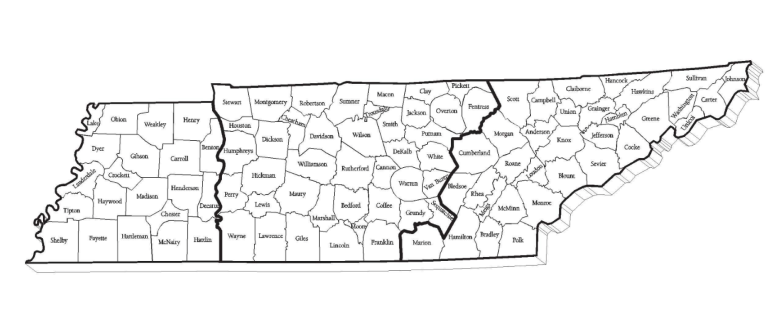
GRAND DIVISIONS MAP
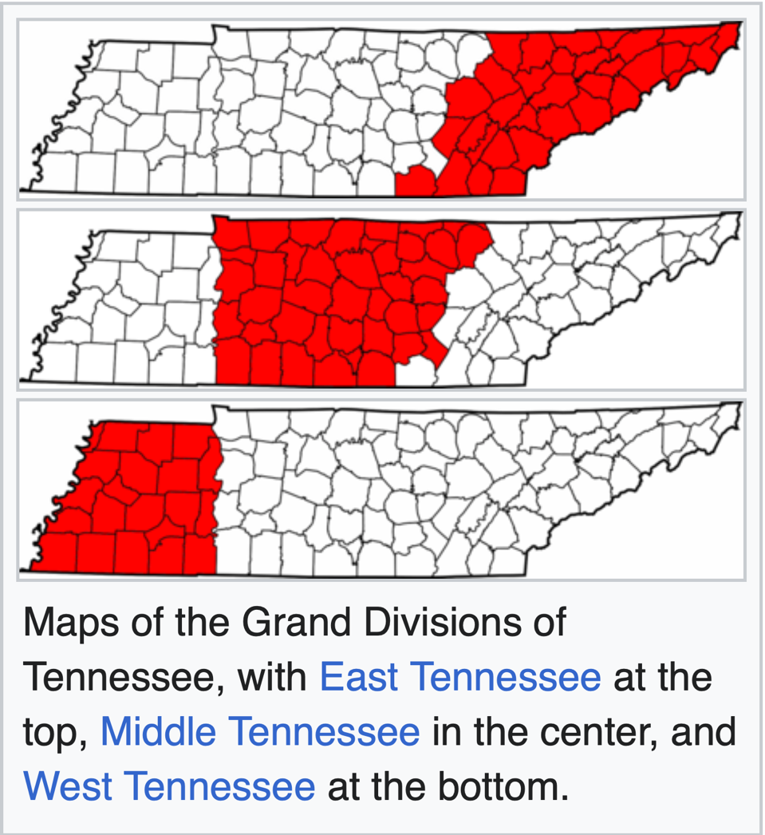

THREE GRAND DIVISIONS COUNTIES

WEST | MIDDLE |  | EAST
Benton | Bedford | Montgomery | Anderson | Morgan
Carroll | Cannon | Moore | Bledsoe | Polk
Chester | Cheatham | Overton | Blount | Rhea
Crockett | Clay | Perry | Bradley | Roane
Decatur | Coffee | Pickett | Campbell | Scott
Dyer | Davidson | Putman | Carter | Sevier
Fayette | DeKalb | Robertson | Claiborne | Sullivan
Gibson | Dickson | Sequatchie | Cocke | Unicoi
Hardeman | Fentress | Smith | Cumberland | Union
Hardin | Franklin | Stewart | Grainger | Washington
Haywood | Giles | Sumner | Greene
Henderson | Grundy | Trousdale | Hamblen
Henry | Hickman | Van Buren | Hamilton
Lake | Houston | Warren | Hancock
Lauderdale | Humphreys | Wayne | Hawkins
Madison | Jackson | White | Jefferson
McNairy | Lawrence | Williamson | Johnson
Obion | Lewis | Wilson | Knox
Shelby | Lincoln | Marion4b | Loudon
Tipton | Macon |  | McMinn
Weakley | Marshall |  | Meigs
 | Maury |  | Monroe

THE REPUBLICAN PHILOSOPHY

We believe:

- The right of the individual to achieve the best that is within him, if he respects the rights of others, is the source of our Nation's strength.
- Government exists to protect the freedom of opportunity in which everyone’s creative ability can flourish.
- Government activities should be limited to those things that people cannot do at all or can-not do so well for themselves.
- The most effective government is government close to the people.
- That both government and society should assist those who cannot provide for themselves, but that every effort should be made to help them become self-supporting, productive citizens with pride in their independence.
- Equal rights, equal justice and equal opportunity belong to all, regardless of race, creed, age, sex, and national origin.
- The preservation of our Nation and the security of our citizens depend upon the Constitution, the laws and the courts, and that respect for them is the responsibility of every individual.
- Government is accountable for maintaining sound money and a responsible economy. Individual rights, liberties, and properties are continually eroded when citizens are op-pressed by excessive taxation, inflation, government waste and over regulation.
- Government is responsible for national defense and that only a strong America can remain a free America.
- It is essential to maintain a strong national defense posture in order that we may, always, negotiate from a position of strength, not weakness, in our continuing efforts toward world peace and friendship.

These concepts are the foundation of our national strength and that the Republican Party, which is committed to their preservation, is the party of today and the party for the future.

THE NINETEENTH AMENDMENT

On June 4, 1919, the 66th U.S. Congress passed the 19th Amendment to the Constitution of the United States. To complete the adoption of the amendment (which would give women the right to vote), three-fourths of the states had to ratify the amendment.
In Tennessee, Governor A. H. Roberts convened the General Assembly on August 9, 1920. Among those in the legislative body was Harry T. Burn (R) of McMinn County, the youngest member of the House. He was not pledged to either side of the issue.
Ratification was a hard-fought battle in Tennessee. Suffragists and Antis had been in Nashville all summer preparing for the fight. Both sides made the Hermitage Hotel their headquarters during this time.
On August 19, 1920, the amendment came up for a vote amid yellow roses worn by the suffragists and red roses worn by the Antis. A motion was made to table the amendment. If that motion passed, the 19th Amendment would be dead in Tennessee. The motion was defeated by a tie vote.
A vote on the original motion, the ratification of the 19th Amendment, was called. The Suffragists knew they had 48 votes, one short of a majority of 49. As the roll was called, Harry T. Burn was the member of the General Assembly who cast the much needed 49th vote. The motion passed 49 to 47.
Why had Harry T. Burn voted to ratify the 19th Amendment? This is how Mr. Burns explained his vote to his colleagues on the House floor the day after the vote, “I know that a mother's advice is always safest for her boy to follow, and my mother wanted me to vote for ratification.”
Mrs. J. L. Burns of Niota, Tennessee, had written the following letter to her son and he had it in his pocket on August 19, 1920.

Dear Son:
Hurrah and vote for suffrage! Don't keep them in doubt! I notice some of the speeches against. They were bitter. I have been watching to see how you stood, but have not noticed anything yet. Don't forget to be a good boy and help Mrs. Catt (Carrie Chapman Catt) put the "rat" in ratification.
Your mother

**Reprinted in the Directory and Bylaws of TNFRW with permission of the family of Harry T. Burn.
TENNESSEE FEDERATION OF REPUBLICAN WOMEN

OUR HISTORY

Republican Women's Clubs have existed for over 100 years. The oldest Club on record was founded in Salt Lake City in the late 1800's. Miss Marion E. Martin, the oldest Assistant Chairman of the Republican National Committee, held an organizational meeting in Chicago in 1937, which led to the founding of the National Federation of Republican Women during a conference held at the Palmer House in Chicago on September 23-24, 1938.

The organization originally was known as the National Federation of Women's Republican Clubs of America. The name was changed in January 1953 to the National Federation of Republican Women (NFRW).
The seal of the NFRW is the American Eagle, king of birds, holding a quill pen and standing guard over our most treasured tool of democracy - the ballot box. The seal was adopted at the Biennial Convention in 1944.
Before the ratification of the 19th Amendment, Mrs. Tom J. Davis of Chattanooga organized Republican Women in her district to work for Republican candidates. The founder and first president of the Tennessee Federation was Mrs. Alice Elder (1955-62). Lillie Helton, charter member of Hamblen County Republican Women, remembers traveling to Mrs. Eider's home on Elders Mountain in Chattanooga and working with a group of women as they organized clubs in the third district and also other districts across the state before Tennessee became affiliated with the National Federation.

Women from Tennessee who served on the Republican National Committee were:

NAME | DATES SERVED
Mrs. Mary Giles Howard* | 1924-1929
Mrs. Beulah Overall Hughes | 1928-1932
Mrs. Ruby Roach McLane | 1942-1953
Mrs. Lupton Patton | 1955-1960
Mrs. Irene B. Parker | 1960-1964
Mrs. Louise G. Reece | 1964-1967
Mrs. Peggy Spurrier | 1967-1976
Mrs. Jeanne Geraghty | 1976-1984
Mrs. Maida Pearson | 1987-1994
Mrs. Alice Algood | 1994-1997
Mrs. Lilian Coker | 1997-2000
Mrs. Stephanie Chivers | 2000-2008
Mrs. Peggy Lambert | 2008-2016
Mrs. Beth Campbell | 2016 –

*Mrs. Mary G. Howard served as an associate member of the RNC

TENNESSEE FEDERATION OF REPUBLICAN WOMEN
PAST PRESIDENTS
1955-1962 | Alice Elder (Mrs. Garrison) | Chattanooga
1963-1966 | Julia Bales Calloway | Morristown
1967-1969 | Ann Tuck (Mrs. James R.) | Nashville
1970-1973 | Ruth Tobias (Mrs. Melvin) | Signal Mountain
1974-1077 | Dorothy Clawson (Mrs. John) | Morristown
1978-1981 | Eleanor Rooks (Mrs. Ned) | Brownsville
1982-1983 | Frances Turner (Mrs. Tom) | Murfreesboro
1983 | Louise Chamberlain (Mrs. Buford) | Greeneville
1984-1987 | Reba Brown (Mrs. Hebert) | Chattanooga
1988-1991 | Ellida Fri (Mrs. Jim) | Memphis
1992-1993 | Marcy Hale | Brentwood
1994-1997 | Barbara McAndrew (Mrs. V. J.) | Dandridge
1998-1999 | Shirley Curry | Waynesboro
1999-2001 | Claire Bawcom (Mrs. Richard) | Franklin
2001-2003 | Betty Cannon (Mrs. Jim) | Nashville
2004-2005 | Annette Pannell (Mrs. Winston E.) | Kingsport
2006-2009 | Shirley Ward (Mrs. Doug) | Covington
2010-2011 | Susan Witcher (Mrs. Ken) | Red Boiling Springs
2012-2013 | B. Claire Crouch | Cosby
2014-2017 | Linda D. Buckles (Mrs. John W. Jr.) | Kingsport
2018-2021 | Barbara Trautman (Mrs. Bob Jr.) | Germantown
2022-2023 | Linda Kollmann (Mrs. George) | Nashville
2024-2025 | Sharon Boreing (Mrs. Forrest) | Jonesborough

TENNESSEE FEDERATION OF REPUBLICAN WOMEN
NOTES

________________________________________________________________________________________________________________________________________________________________________________________________________________________________________________________________________________________________________________________________________________________________________________________________________________________________________________________________________________________________________________________________________________________________________________________________________________________________________________________________________________________________________________________________________________________

